**Practice Question 1**

*A university administration would like to create a database with information about the buildings located at many campuses owned by the university.*

*The university consists of several campuses located in the various cities all over the country. Some of the cities host more than one campus, however each campus is located in one city. The campuses have their unique names, and unique address. An address consists of city name, street name, and a number of building that host campus administration.*

*A campus consists of a number of buildings. Each building is identified by a number within a campus. Each building is either general teaching building or staff building, or administration building. Additionally each building is described by total number of floors, and optional name.*

*The buildings consists of rooms. A room is described by a number and area. Room number is always unique within a building.*

Your task is to create a conceptual schema of the sample database domain given above and to draw such schema in a notation of UML simplified classes of objects.

## Practice Question 2

Read the following specification of a sample database domain.

*A network of hospitals consists of the hospitals with the unique names located at unique address. An address consist of city name, street name, and building number.*

*Each hospital employs a number of doctors and nurses. Doctors and nurses are described by an employee number, which is unique at a hospital, first name, last name, phone number and optional email address.*

*A group of doctors who are specialists has their specialist license numbers recorded together with a name of a group of specialists they belong to. All doctors are additionally described by a practitioner license number and their planned specialisation.*

*Patients are treated at the hospitals. A treatment is described by start date/time, end date/time, doctors involved and the names of medical procedures applied.*

Your task is to create a conceptual schema of the sample database domain given above and to draw such schema in a notation of UML simplified classes of objects.

**Practice Question 3**

Consider a conceptual schema given below.

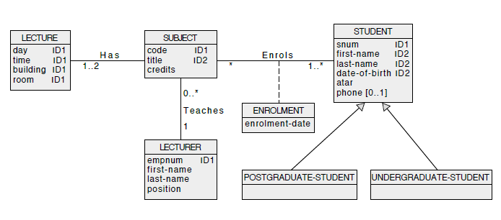

Your task is to perform a step of logical database design, i.e. to transform a conceptual schema given above into a collection of relational schemas.

For each relational schema created clearly list the names of attributes, primary key, candidate keys (if any), and foreign keys (if any). Assume, that **superset method** must be used to implement a generalization.